“Program Logic Controllers”

1. Program logic controller
   1. Controllers – event driven controllers

Ex. Automatic drilling machine:

1. control components: drilling machine / workpieces
2. event procedure

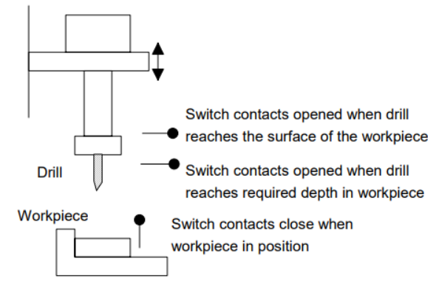

Start lowering the drill

Start drilling

Stop drilling

Retract the drill

* + 1. microprocessor controlled system
    2. The programmable logic controllers - PLC
  1. Hardware

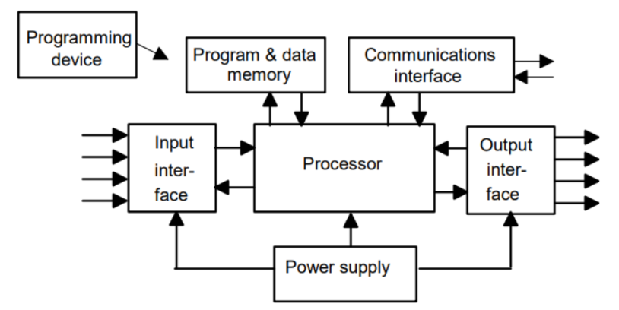

-processor / CPU

-power supply unit

-programming device

-memory unit

-the input and output interface

-- discrete / digital / analog signal

-communication interface

* 1. 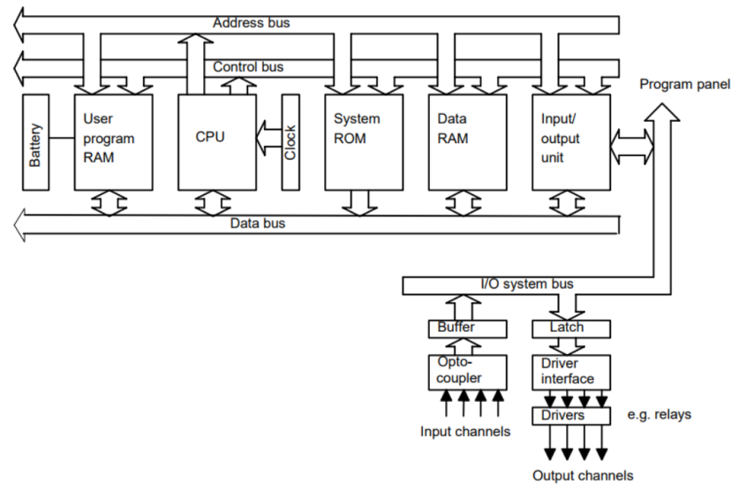Internal architecture

-. Bus : address, data, control, I/O system

1.3.1 The CPU

-Arithmetic and logic unit(ALU) :

+arithmetic : add, subtract

+logic: AND,OR,NOT, EXCLUSIVE-OR,..

1.3.2 The buses

The buses; the paths used for communication within the PLC

1.3.3 memory

-ROM , RAM, EPROM

1. 1bits, 8-bit word , 16-bit word
2. Memory size: 1K = 210=1024

Memory : 4K x 8 = 4 x 8 x1024 (bits) = 4 x 1024 (bytes)

1.3.4 Input/output unit

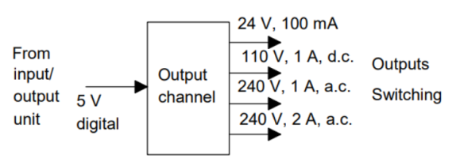1) For isolation, optoisolators(optocoupler)

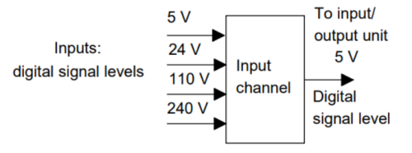

* 1. PLC systems
* A single box ,modular/rack type
* Typical PLC: 6,8,12 or 24 inputs and 4,8, 16 outputs
* Mitsubishi Compact PLC

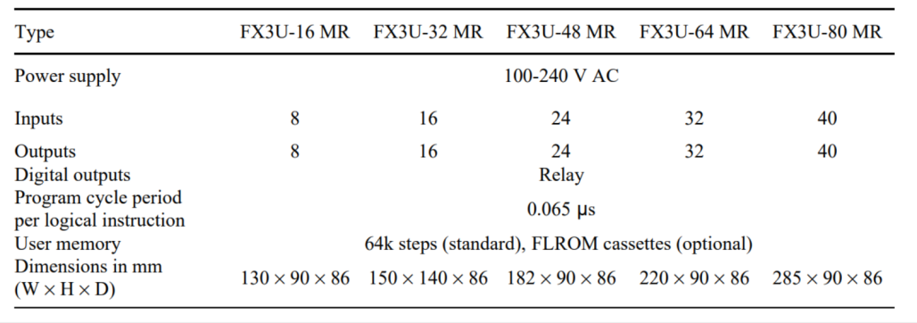

* + 1. Programming PLCs

1. Hand-held programming device /Desktop consoles/Personal computers
2. Programming software: different from the manufacturers

-Mitsubishi(MELSOFT), Siemens(SIMATIC STEP 7)

**-International IEC61131-3**

2. Input-output devices

2.1 Sensor, transducers

1) types

- sensors: measure a specific physical terms

+ temperature , humidity, resistor,..

+ inertial sensors: IMU – accelerometer, gyroscope

-transducers : convert a physical form to a another form

+piezo(electrical 🡨 🡪 mechanical), motor,..

2)Performance

- Accuracy : +/- %, non-linearity , hysteresis error

-range(measurement)

-dynamics:

+ response time (time to 95% of the steady state with a step input)

+rise time: time from 10% to 90 or 95% of the steady state value

+settling time: time for the output to settle within 2% of the steady state value

-sensitivity:

+output change / to be measured input change

+ex. Thermocouple ( 20

-stability / drift / zero drift

-repeatability

-reliability

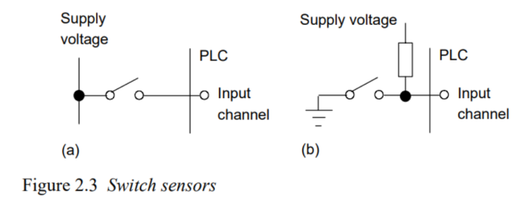2.1.1 Mechanical switches

What is different? Why?

We may call a pull-up resistor

2.1.1 limit switch

detect the presence or passage of a moving part

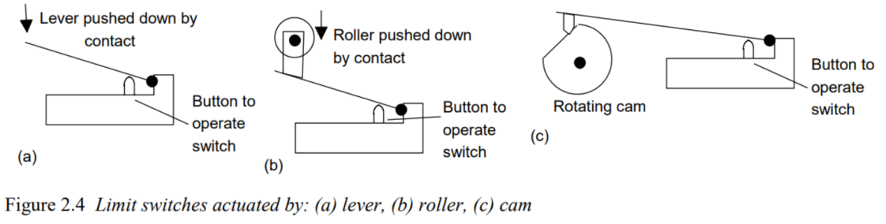

2.1.2 Proximity switch

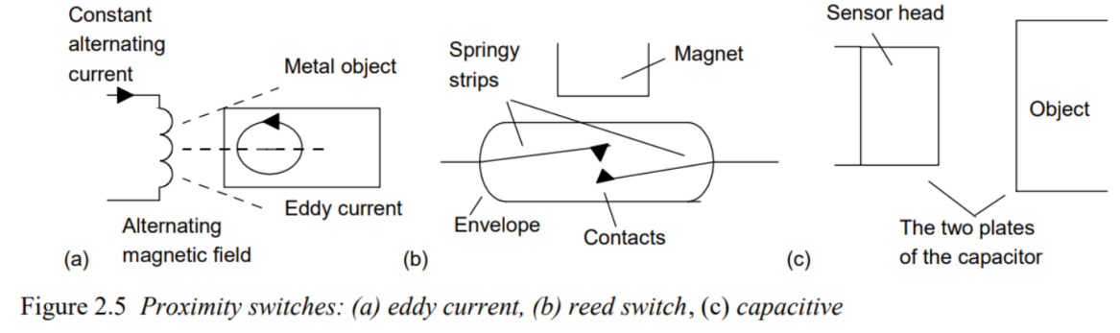

2.1.3 Photoelectric sensors and switches

- transmissive/ reflective /

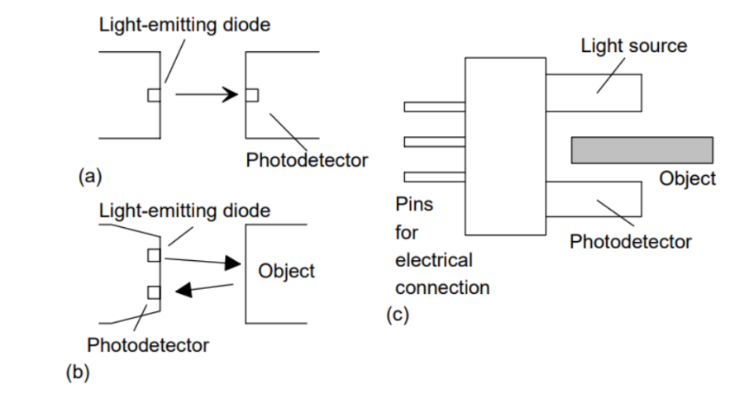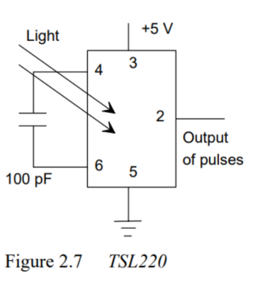

2.1.4 Encoders

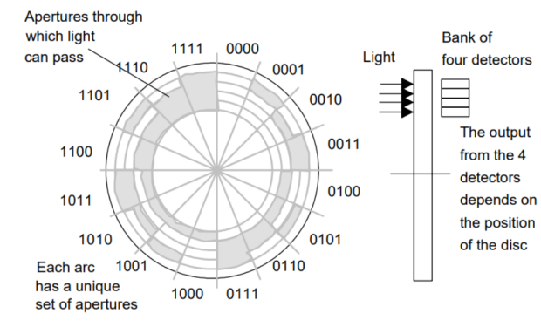

2.1.5 temperature sensor

- Bimetallic

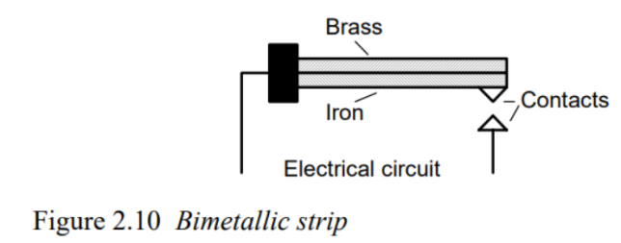

-Resistive temperature detector – Wheatstone bridge

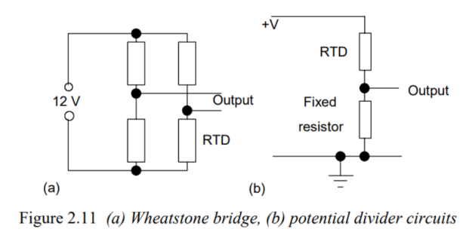

-thermocouple : contact type

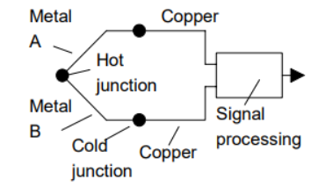

2.1.6 position / displacement sensor

- potentiometer

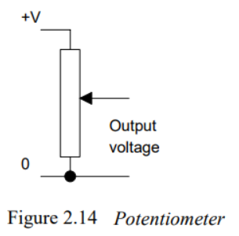

-LVDT(linear Voltage Differential Transformer)

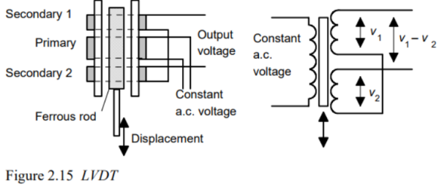

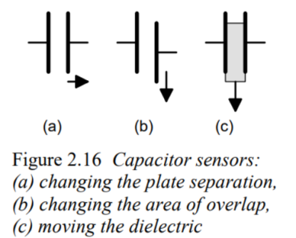

-Capacitive type

2.1.7 Strain gauges

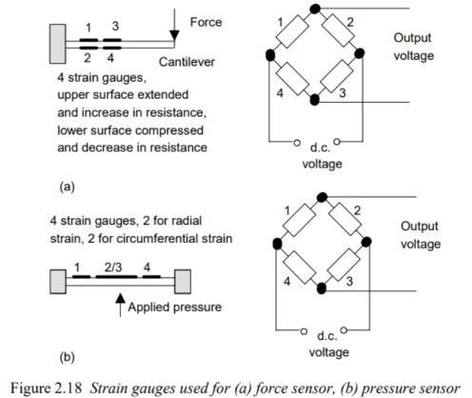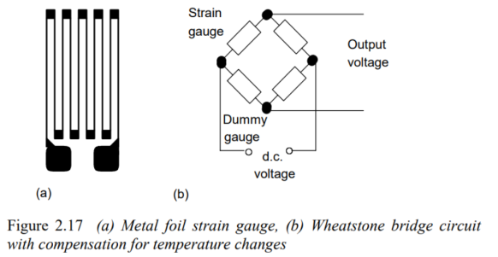

2.1.8 pressure gauge / pressure swith

2.1.9 Liquid level detector

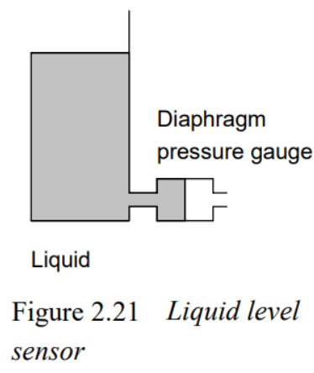

2.1.10 Fluid flow measure

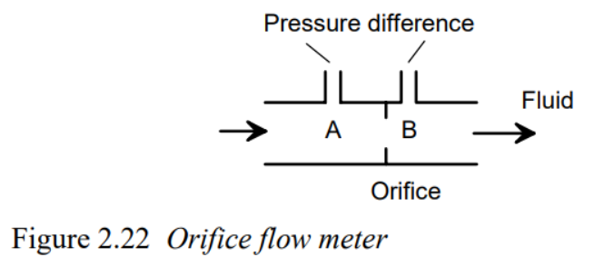

2.2 Output devices

2.2.1 Relay

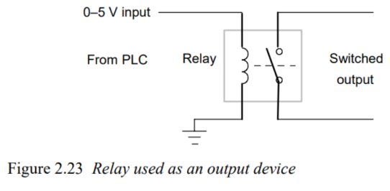

2.2.2 Directional control valve

2.2.3 Motors

- armature / field coil / brush / commutator

- PWM(pulse width modulation)

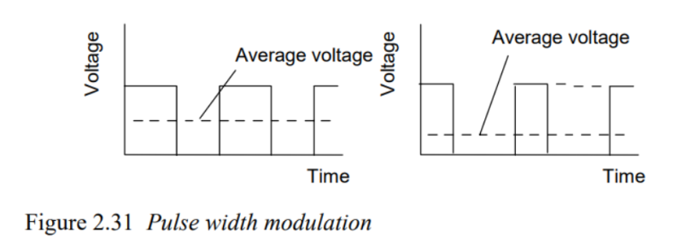

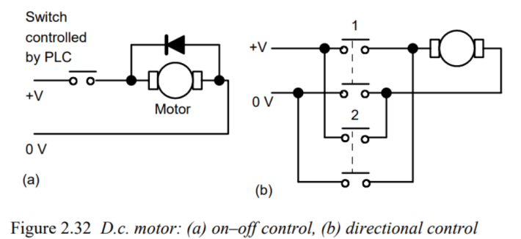

Why is it needed?

* Brushless motor

2.2.4. Stepper motor

- Stepper motor: For each pulse input, it rotates each angle.

-direction : unipolar / bipolar

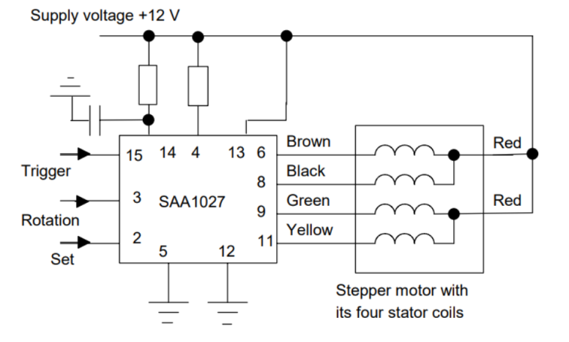

1. Number systems
   1. Binary system

-LSB / MSB

* 1. Octal and hexadecimal
* Octal : 3bits(0,1,2,…,7)
* Hexadecimal : 4 bits(0,1,2,…,9,A,B,C,D,E,F)
* BCD(binary code decimal) : 4bits

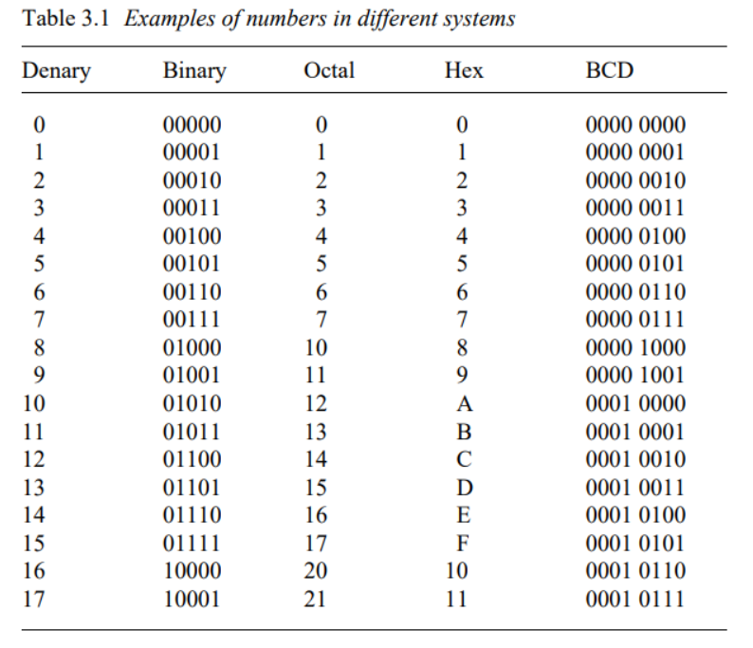

1. Ladder and Functional Block Programming

Introduction

* S/W

+Machine code / Assembly language / High level language ( C, C++. Matlab, Ladder programming)

* Ladder programming : depends on the PLC manufactures
* International standard: IEC 1131-3(International Electrotechnical Committee)

+ Ladder programs(LAD)

+Instruction List(IL)

+ Sequential Function Charts(SFC)

+ Structures Text(ST)

+ Functional Block Diagram(FBD)

* 1. Ladder Diagram

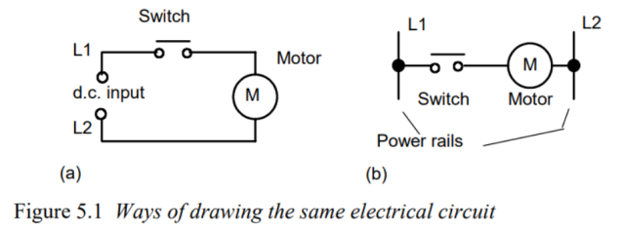

* 1. Logic function

5.2.1 switch

* Standard IEC 1131-3 symbols

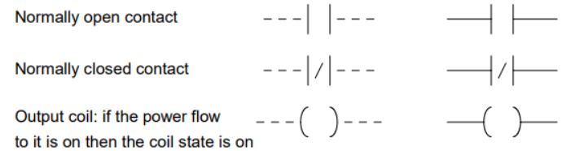

1. Timing diagram

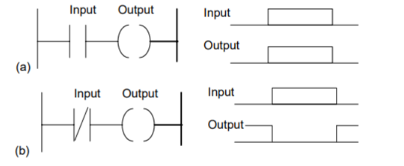

1. Element name(variable) , and Address

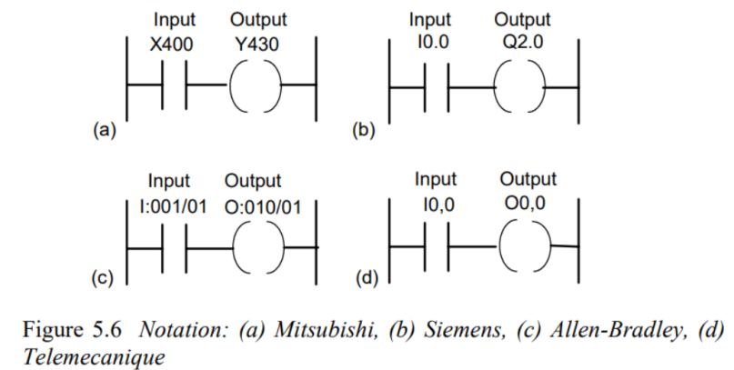

5.2.2 AND

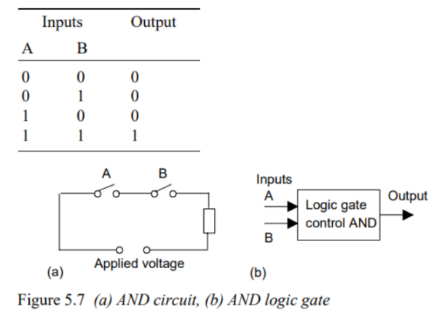

* Ladder and timing

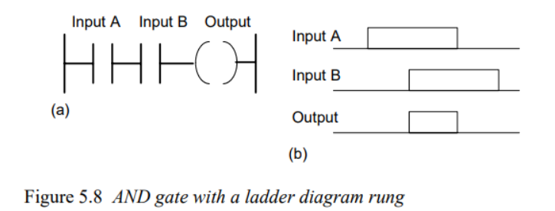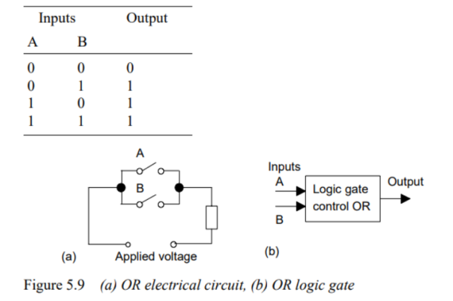

5.2.3 OR

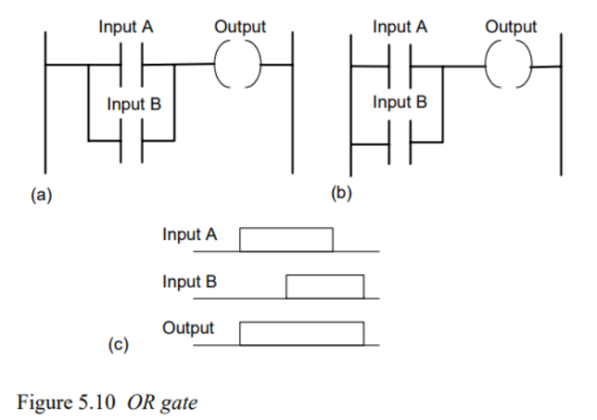

5.2.4 NOT

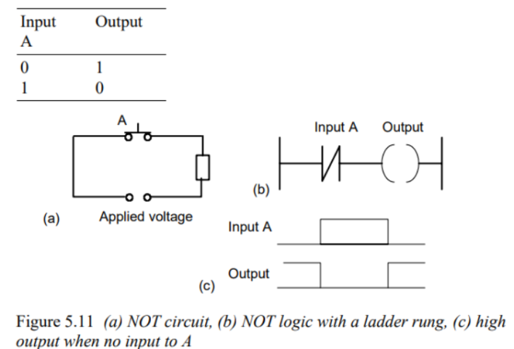

5.2.5 NAND

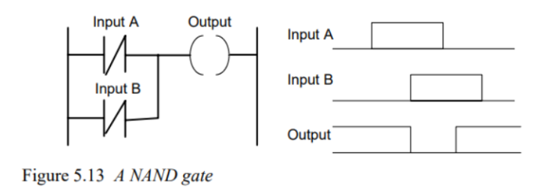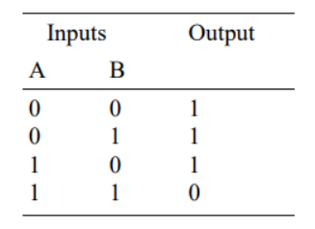

5.2.5 NOR

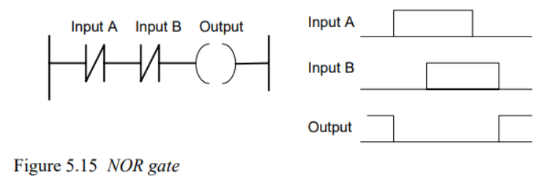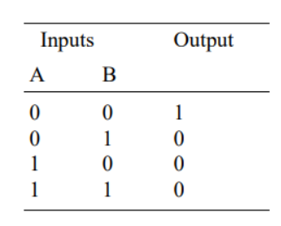

5.2.5 XOR

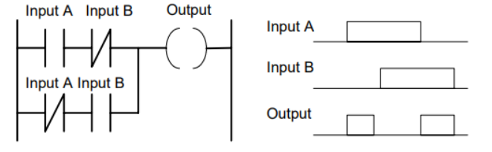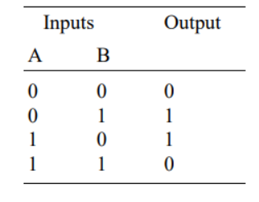

* 1. Latching

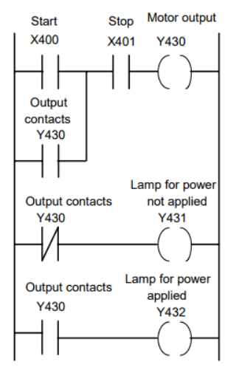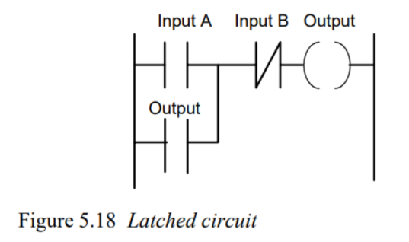

* 1. multiple output

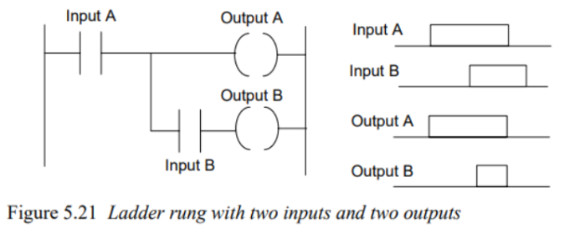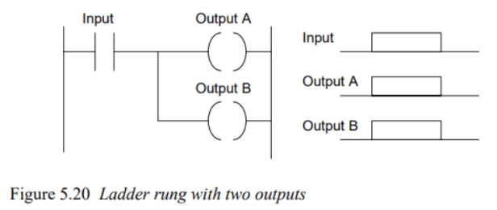

* 1. Entering Program
  2. EFunction Block

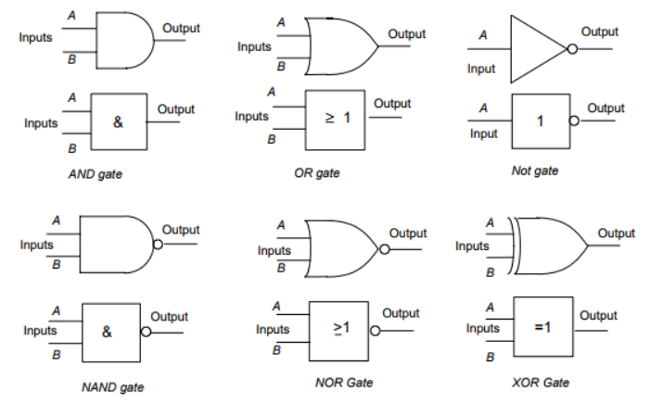

Example

